Utility Costs in Different Houses: It’s Not Easy Being Green!

PSY 200-999 Example Final Project
By I.M. Stüdent
Missouri State University

Abstract
I compared electricity, gas, and water consumption at my old house and my new house. There were significant increases in electricity costs and water costs, although no significant differences were found in gas costs. I discussed the results in terms of behavioral differences of the residents rather than energy efficiency of the houses, and I offer several suggestions for lowering utility costs in the future.

Utility Costs in Different Houses: It’s Not Easy Being Green!
The environment is currently one of humankind’s biggest problems. Global warming is occurring, oil reserves are dwindling, and potable water is becoming more scarce (Smart & People, 2010). It is extremely important that each of us investigate how wisely we are using Earth’s resources and make an effort to conserve wherever we can. One of the best ways we can do this is to examine our utility consumption around the house.
Everybody who lives in Springfield, Missouri receives monthly reports about utility consumption from City Utilities. With this information, anyone can (and should) track their utility use to determine whether any resources are being wasted. The goal of this project is to compare utility use between two different houses. My housemates and I moved to a new house nearly a year ago, but we could not know in advance how our new house would compare to our old house in terms of energy efficiency.
Before I entered or analyzed my data, I predicted that our new house would differ from our old house in terms of energy efficiency. It is possible that our new house is more energy efficient than our old house, but it is also possible that our new house is less energy efficient than our old house. Therefore, instead of making directional hypotheses, I am simply predicting that there will be some difference in energy efficiency. In other words, the statistical tests I use will be two-tailed.

Method
My data were collected by taking the information about utility use from our City Utility report, which is mailed to our house every month. Although the nature of this comparison could potentially be considered between-groups, because it is comparing uses across two different houses, I believe it would be more appropriate to consider this a within-groups comparison, because it is tracking the utility use of the same people across two different houses. Because one could expect that the same people would have similar utility expenditures at different houses, it is reasonable to assume non-zero correlations in utility use at each house, so paired-samples comparisons make more sense.
Results
The data are expressed in terms of how much money we spent in utilities each month. Data are not included for the months of May, June, or July because there are not data available from both houses in those months. The alpha for all statistical tests was set at .05.
I first verified the assumption that utility use would be correlated between the two houses. See Figure 1. Surprisingly, the correlation was quite weak, r(7)=.02, p=.97, and not significantly different from zero. This may have been due to an outlier from the month of August, which produced much higher costs than any other month ($410, compared to an average of $230, with a standard deviation of 73.86). Because the utility costs in August were about 2-3 standard deviations away from the mean of the monthly utility costs of the new house, it is reasonable to consider August to be an outlier and exclude it from analyses. When this is done, the correlation is substantially higher, r(6)=.61, p=.11. Although the correlation coefficient is not significant at the level of .05, it is approaching significance, so the use of paired-samples statistical tests is reasonable.
Next, I examined the total utility costs by comparing the sum of electric, gas, and water costs from both houses. See Figure 2. A paired-samples t-test revealed no significant difference, t(7)=0.88, p=.41. However, the energy consumption at each house could differ in multiple ways. The new house might have been more efficient for gas, but less efficient for electricity, so individual utilities should be compared separately.
Figure 3 displays comparisons between the old house and new house by specific utility. One can visually see the large variability (portrayed by large error bars) for each utility, which probably reflects the fact that specific utility varies throughout the year. (For example, more gas is used in the winter but more water is used in the summer.) Starting with electricity, a paired-samples t-test revealed a significant difference, t(7)=3.29, p=.01, such that average electricity costs were higher in the new house compared to the old house by approximately $30/month. There was no significant difference detected in gas costs between the two houses, t(7)=1.29, p=.24, although the costs were numerically lower in the new house. Finally, the difference in water costs was significant, t(7)=2.33, p=.05, such that water costs were higher in the new house again by approximately $30/month.
Discussion
There were significant differences in utility costs between the two houses, and unfortunately the data suggest that utility costs tend to be higher at the new house. However, this does not necessarily mean that the new house itself is less energy efficient; living in a new house can trigger new behaviors that produce differences in costs. For example, the new house has a sprinkler system for the yard, which could contribute to higher water use by making it more convenient to water the lawn. In the old house, we may simply have been lazy about watering the lawn and unintentionally conserved water. Likewise, the new house is somewhat larger than the old house, so increased energy usage may stem from having more rooms to light. With a larger house, residents may be more likely to spread out and require light in separate rooms, whereas in the past we may have been more likely to share common areas.
Because I did find significant differences in utility use between the two houses, and they had not improved in the new house as I had hoped, my conclusions are clear: I need to be more environmentally friendly in my utility use. I will set the sprinkler system to operate less often and for shorter periods of time in order to conserve water. I will make more of an effort to turn off lights when I am not in rooms. And even though gas costs were lower (nonsignificantly) in the new house, I can still make an effort to keep the thermostat lower next winter. Hopefully, if I conduct these analyses again next year I will find significant reductions in utility use.
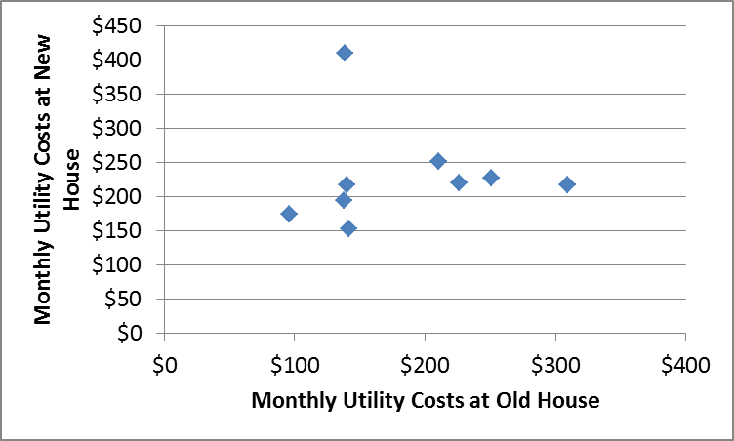
Figure 1. Scatterplot between montly utility costs at the old house vs. the new house.
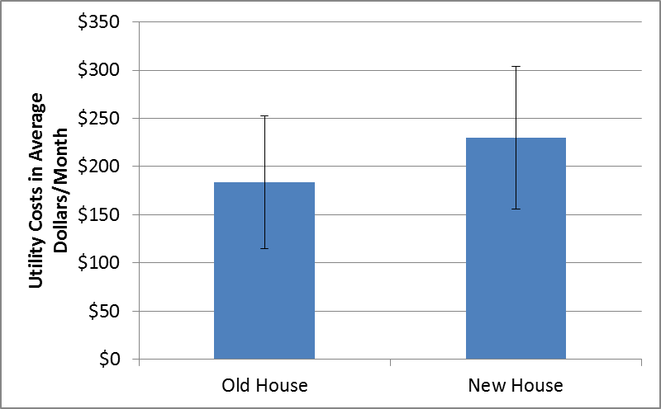
Figure 2. Comparison of average total utility costs (electric, gas, and water) between the old house and the new house. Error bars represent standard deviation.
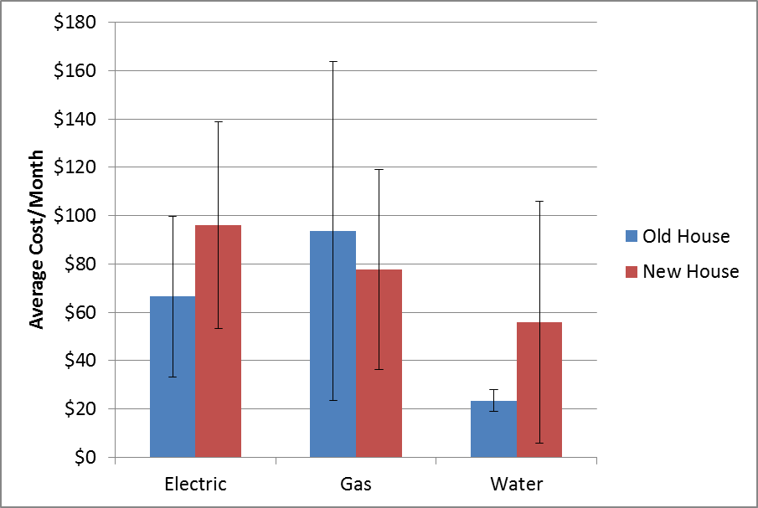
Figure 3. Comparison of average utility costs separated by electric, gas, and water between the old house and the new house. Error bars represent standard deviation.

